Worksheet 1- Airport Codes Using Dictionaries

# Scenario

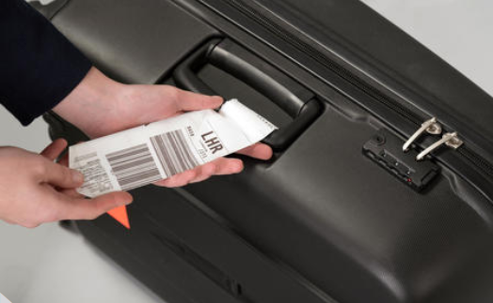

An airports code is simply a location identifier for airport around the world. It is a three- letter code defined by the International Air Transport Association. You will find such code on your luggage bar code and on your tickets. Airport codes are very convenient to pilots for location identification and their communications. The table below shows some of the airports and their code:

|  |  |
| --- | --- |
| **Airport code** | **Airport** |
| LHR | London Heathrow |
| MAN | Manchester |
| BHX | Birmingham |
| EDI | Edinburgh |
| LTN | London Luton |

In this exercise, you are asked to create a program to store airports names and their codes in a dictionary structure. **The program MUST use dictionaries to store the data.**

# Part A

## Activity 1

1. The data in the table above can be represented by a single dictionary named airports.

Airport={"LHR": "London Heathrow", "MAN": "Manchester", "BHX": "Birmingham", "EDI": "Edinburgh", "LTN": "London Luton"}  
print(Airport)

1. Research the advantages of using dictionaries, then write five lines summarising your research.

An advantage of using dictionaries is that it allows you to store a key and a value in programming which allows you to create a list. Another advantage is that you can add key values without using “append”, therefore the program will be much simpler.

## Activity 2

A user wants to add more airports to the one you have created in activity 1.

Add a **procedure** to allow user adding more airports (any number) using an appropriate loop. The procedure should ask user if they want to enter a new airport details. If the user answers yes, the procedure should allow user to enter airport name and code, and add them on the existing dictionary. If the user answers no, the procedure returns.

In order to complete this task, you need to:

**1) Write Pseudocode for the procedure described above.**

**2) Write Python code to show the procedure will work.**

**3) Test the procedure by adding the following airports.**

**Airport code Airport**

NCL Newcastle

XQH Nottingham

PIK Glasgow

EXT Exeter

## Activity 3

In activity 2, you have added the airport details before you validate the data entry.

Add a function that validates the data before saved on the dictionary. The airport key should only be 3 letters, and the airport name must be string and must be entered.

If the data is valid, it can be added to the dictionary otherwise, appropriate message should be displayed.

**1) Write pseudocode for the procedure described above.**

**2) Using Python, write the procedure as described above.**

## Activity 4

The user wants to search for the airport given the code. For example, the user will enter the airport code “LHR” and the program returns the airport name “Heathrow”.

Add another function that allows the user to search for an airport in the dictionary. The program will ask user to enter airport code, and will search it in the dictionary. If the code found, the function returns the airport name, otherwise it returns appropriate message such as airport not exist. In order to complete this activity, you need to:

**1) Write pseudocode for the procedure described above.**

**2) Write Python code to show the procedure will work.**